

**Linux Architecture**

# Introduction and/or Background

The linux system is broken into blocks like so -

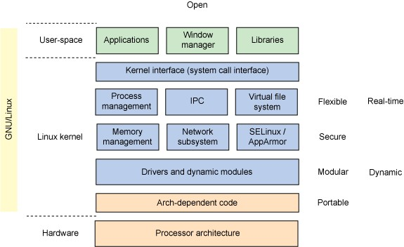

That is broken down into three layers -

1. Kernel Space - Core services reside here. It's where the essence of services, system calls and port responses are located. The kernel is modular so it is possible to add or delete options as you need them. For example, suppose you have a device that does not have USB hardware. Likely the distribution you loaded has the USB kernel drivers loaded by default. It is possible to remove that driver and speed up the overall system by some measure.

Example of kernel space output using the lsmod command:

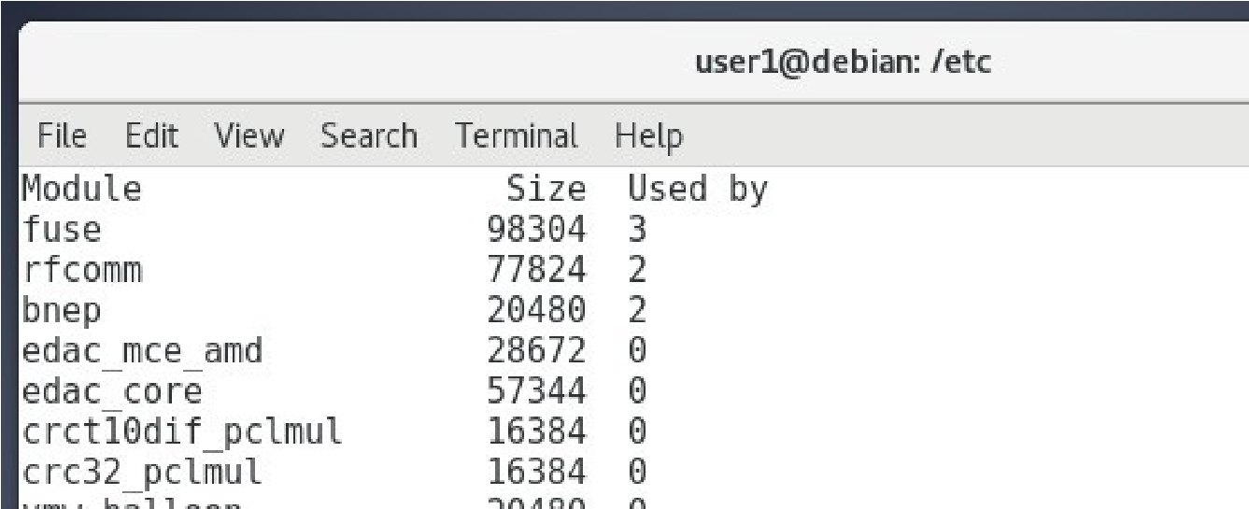

1. User Space - This is where the shell, user applications and BASH live. Terminal for example is a user space application. You think you are talking to the kernel but in reality you are not. BASH is there as an intermediary between your commands and the kernel that reacts to it. You never really talk to the kernel directly.

An an example of user space output using the df -h command:

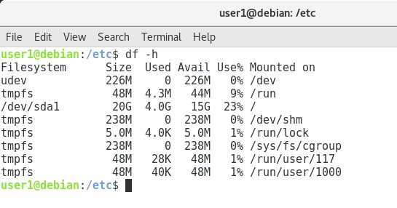

Visually, it’s not much different. lsmod provides information on the kernel queue whereas df displays storage information.

1. X Windows Space - X is a special case. It provides messaging between the kernel and user spaces. Click on an icon and a request is sent to BASH in user space that is then forwarded to kernel space for response. Talk to a developer and they will respond, "Ugh that's X stuff. I don't touch it. It's in user space!" Technically correct but many make the argument it is part of a three layer cake of architecture -
   1. User
   2. GUI
   3. Kernel

# Objectives

In this project/lab the student will:

●

**Equipment/Supplies Needed** ● As specified in Lab 0.0.1.

# Procedure

Perform the steps in this lab in the order they are presented to you. Answer all questions and record the requested information. Use the Linux Virtual Machine to perform lab activities as directed. Unless otherwise stated, all tasks done as a non-root user. If root access is needed use the sudo command.

# Assignment

Launch Debian.

Open Terminal and issue the following command -

## 1. df

Record a screenshot in a Word or Writer document. Do it again but with an option this time –

## 2. df -h

**Note:** the df command provides two formats as you have seen. the -h format you might be used to, its Windows like in its output, reporting data in Mb, Gb, Tb sized chunks. But you might be wondering about blocks.a block is a synonym for sector x track x disk, ideas you leaned from your

PC class. Unix/Linux predates Microsoft and there were many forms and disk storage technology back then. A Unix system being able to interoperate with different vendors tech had to get in the dirt and define the characteristics of the storage system to the OS. The block is how they solved it.

Record a screenshot in a Word or Writer document. While still in Terminal issue a clear command. At the prompt execute –

## 3. lsmod

Record a screenshot in a Word or Writer document.

Look for the cdrom kernel entry in the lsmod output.



What is the size in bytes of that module? 5bytes

Place that answer in the Word or Writer document.

Lab Submissions Proof: Provide screenshots as indicated in the lab; upload your proof to Moodle for grading. At your option explore the other other kernel modules and take a guess at which ones may not be applicable to your particular PC.

# Rubric

Checklist/Single Point Mastery

|  |  |  |
| --- | --- | --- |
| Concerns  Working Towards Proficiency | Criteria  Standards for This Competency | Accomplished  Evidence of Mastering Competency |
|  | Criteria #1: Provide a screenshot showing you have successfully executed the df command  (25 points) |  |
|  | Criteria #2: Provide a screenshot showing you have successfully  executed the df -h command  (25 points) |  |
|  | Criteria #3: Provide a screenshot showing you have successfully  executed the lsmod command  (25 points) |  |
|  | Criteria #4: Correctly identify the size of bytes in the cdrom kernel entry  (25 points) |  |